Technology in the life of a shy “good girl”

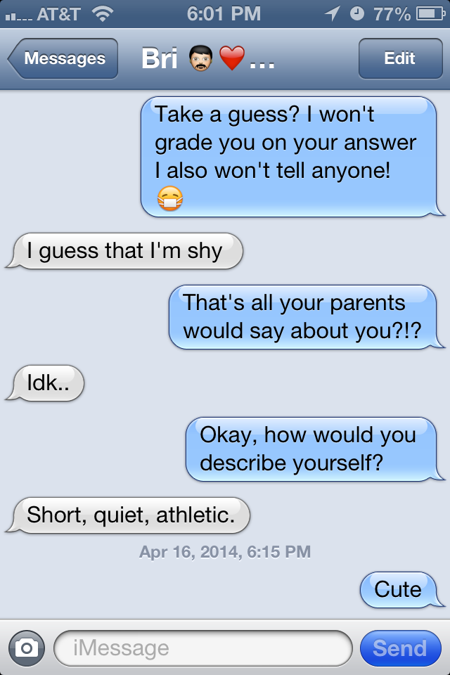

Krista McAtee
EDCT 556
Dr. Jessica Parker
Sonoma State University
April 27, 2014

Introduction
In my search to discover “what it is like growing in a digital age” I chose to study a fourteen-year-old Latina youth because I was interested in how technology shapes identity and more specifically cultural identity. I was also interested in seeing how technology influences identity in terms of gender, class, culture, sexual identity.
Having clear, healthy personal boundaries and limits around technology is easy when you are a “good girl.” Bri is a self-proclaimed “shy, ” girl. She is a fourteen-year-old eighth grade Latina honor roll student and an athlete. Her nuclear family consists of her mom and dad, her twenty five year old sister (who lives on her own with Bri’s baby niece) and her twelve year old sister. Her parents work hard and live paycheck to paycheck, but they make their children’s activities a priority. They rent a small townhouse in a middleclass neighborhood about ten blocks from Bri’s middle school and five blocks from the high school she will attend in the fall. Bri’s parents attend school events and participate in meetings. Both Bri and her younger sister play several sports and the much of the family’s time and financial resources revolve around getting the girls to out of town games and tournaments and supporting their sports activities. Bri plays on a competitive travel soccer team with under eighteen year old girls and plays AAUU travel basketball. She is fast on the court and on the field. She often goes from soccer to basketball practices on the same day after school. Although sports are a big priority, they are not as important as school. There are times when she misses a practice because she has too much homework. It is also very clear that the priorities of the family are first: family, second: academics and third: sports. Bri is a good athlete, a good student, and the good daughter. Her technology use follows that same pattern.

Methodology
The data for this mini ethnography was collected through two observations and an hour-long interview as well as text messages and snapchat conversations. Bri is my daughter’s best friend and is often at our house. They also play basketball on the same three teams throughout the year. The first observation took place at my house when Bri was visiting on an overnight with another friend, Alyiah. My son also had a friend over as did my oldest daughter. There were four guests and my three children in the house. The rages of ages were from 11 to 18. Most of the observation consisted of the three girls on the floor of my living room passing their cell phones and iPod around the group and chatting.
My interview took place at Mary’s Pizza Shack. Although she is not talkative, and the setting was a bit chaotic, it was the best way to gather data from Bri because she is very quiet and shy, so it was difficult getting anything out of her in a group setting. I transcribed and coded the interview. My color-coding system included:
Cultural identity
Academic Identity
Values around technology
Access to technology/connectedness
Technology use
The final field note was conducted during an observation when I picked up Bri from her house, ate dinner with her and my own children at our house and brought the girls to their basketball practice. I stayed and observed the preparation for practice, the warm up and practice itself.
Common themes that came up had to do with connectedness. The importance of connecting with more people and knowing what is going on in the community was highly valued. The theme of cultural identity was present and it seems like there is a bit of ambiguity or uncertainty about Bri’s cultural identity. Bri has a strong sense of herself as the “good girl” in the family, among friends and at school. Those values and that identity was evident in her technology use at home and at school and in her view of herself as an academic, a “good student.”

Technology in the life of a “good athlete” and a “good friend”
Bri’s technology use revolves almost exclusively around her iPhone which she finally convinced her parents to buy her last year because she did not have Wi-Fi and could not keep up with what was happening with her friends. She mostly uses snapchap, instagram and texting. Her favored way of communicating is instagram because it “is a little less casual” and more refined than snapchat. Bri’s preference for Instagram above Snap chat is indicative of the idea of the packaged self explored by Davis and Gardner in The App Generation. (2013). She rather present the better photos that she can chose than the possibly of bad pictures “where you’re really ugly” on snapchat. (Interview, pp. 9)
She really does not use her phone for calling people at all. “It’s more like texting, unless my mom forces me to call them. Its like one time, I think we were trying to make plans with Jessie and my mom was like, “call her right now!” (said in a stern voice). “I’m like, ‘its fine, I can text her!’” (Interview, 2014, pp. 11) She uses very little technology besides her iPhone. For Bri, the main purpose of technology is connecting with others. “I guess if someone had a lot of technology to chose from they are probably really connected, probably know a lot of people. And then if someone doesn’t have a lot, like if someone doesn’t even have a phone, they might not be as well connected. That’s one way to look at it!” (Interview, 2014, pp. 15). Facebook used to be the main way she and her friends stayed connected, but since instagram came out, people liked it and started using it. She and her friends stopped using Facebook. She sees Facebook as the domain of people her of her mother’s generation. As Watkins described the migration from MySpace to Facebook as “driven by a desire to join a more exclusive community.” (Watkins, pp. 86) so was Bri’s desire to move toward Instagram. She and her friends were looking for a community that was not so much a part of the adult culture.
Much of her iPhone use and friendships have to do with friends who she knows because of sports. “Our most intimate bonds online tend to be formed with like-minded people.” (Waktins, pp. 97). Her instagram homepage is full of sport photos and photos with either teammates or family members.
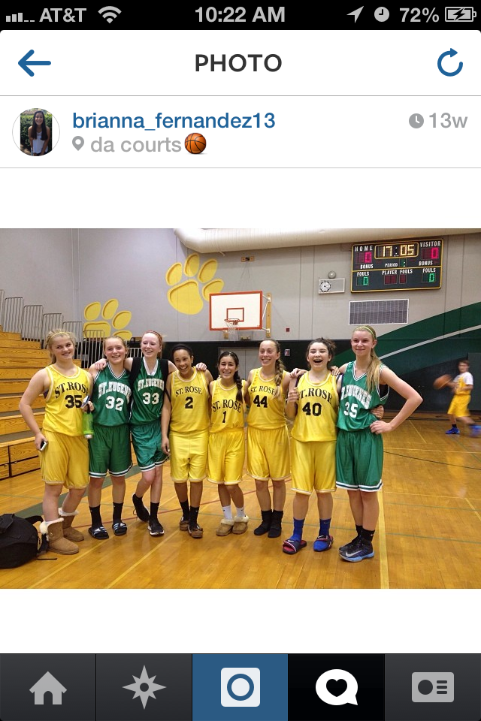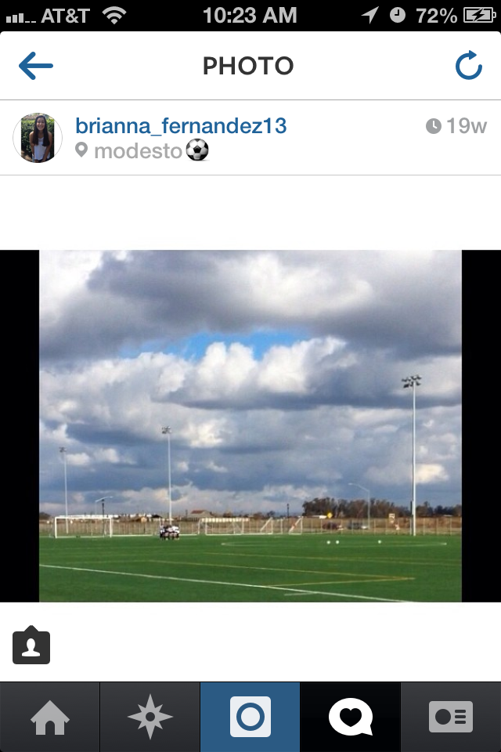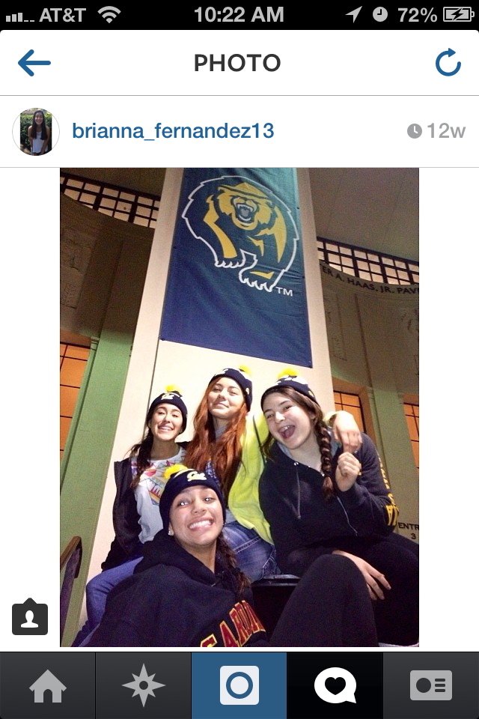
Bri does not engaging in bashing others using technology, even the rival teams. As competitive as the games can get at times, there is not need to be mean. She is know by her teammates and peers as “the sweet one.” She is, however aware of the risks of bullying in today’s technological age. “Well it would be easier for people to bully. It’s not really a good thing. Ya because it is just easier to write it than to actually say it to someone’s face?” (Interview, pp. 16). She understands that somehow the impersonality of technology makes it seem okay to some youth to say hurtful things to others. According to Boyd, Bri is unlike most teens who, “aren’t worried about strangers, they are more worried about getting in trouble.” (2013). She has strategies to keep herself safe online. “Oh ya! That’s why you keep your stuff private. You don’t let anyone on it that you don’t know.” She explained in her interview how she kept things private. “Well like on instagram there is an option to keep your profile on private. I usually follow the other person first and then check their profile if they accept me. If they don’t accept me than I don’t accept them.” (Interview, pp. 15). She hasn’t really experienced bullying or negative stuff online except one time when someone trashed a friend’s instagram. When I asked her about that she said, “It was a long time ago. I don’t remember any more.” She has her own way of establishing an online “gated community.” (Watkins, 2009).

Technology in the life of a “good student”
School comes easy to her and she spends most of her technology use related to school helping friends with their homework as she doesn’t need to rely on technology for her own success in school. This is a good thing because the family’s computer is old and slow! “It’s so frustrating! We are saving up for a new one, that’s better than the old one we used to have plugged into the wall!” (Interview, 2014 pp. 5) She rarely uses a computer or the internet to look up information for school. School is pretty much easy for her, so she doesn’t need to use technology to have academic success. Bri is part of honor’s society and is happy with the role of the studious one in the family. When taking about the different academic expectations of her and her sisters she said, “I don’t mind. I like getting good grades. Except when I get like a “B” they like make fun of me.” (Interview, pp. 3). She is the first child with an iPhone and her parents are starting to loosen up their rules with her because the trust her more than the others. As she compares herself with her sisters she says, “They’re more out loud, crazy and I’m more shy and silent.” (Interview, pp. 3).
Bri is very clear about the rules and expectations concerning technology in school. Although phones are not supposed to be used in class, many students have their phones out in class. Many students listen to music, text, snapchat or use facebook or instagram during class time. She would not think to use her phone in class, “because no phones are allowed at school, only after school. I am scared that if I were to try to bring it, the one time I would I’d get caught.” (Interview, pp. 10). So she leaves it in her backpack inside her locker. She has no interested in participating in risky behavior online, in school, in sports or outside of school that has any potential to get her into trouble of any kind.

Technology in the life of the good daughter
Bri’s parents are the first generation born in the US. Her grandparents were all born in Mexico. At home, her parents speak very little Spanish they say it is hard to speak in Spanish because the girls don’t understand. At times they express regret in not having spoken more Spanish to the girls when they were little. Bri took Spanish in 7th and 8th grade and will enter Spanish 2 Honors at the High School, but she speaks very little Spanish. In the interview she said, “I look Mexican, but don't speak Mexican.” (Interview, 2014, pp. 21) Even simple sayings such as “Que paso” seem hard for her to understand at times.
At times I did not realize the lack of confidence Bri has in her Spanish nor did I realize that there were so many things she did not understand. Knowing that she is used to being very strong and everything she attempts, I see that Spanish might be a struggle for her. She has high expectations for herself and I can see that things that are a bit more difficult for her might be frustrating and might make her less willing to take risks, as with the Spanish language. Cultural identity is something that her peers joke about often. They say that Bri and my son are “Oreos” because they look Mexican (dark on the outside) but they don’t act Mexican so they are white on the inside. My daughter is an “inside out Oreo” because she doesn’t look Mexican, looks white on the outside, but acts more Mexican (dark on the inside) because she understands and speaks Spanish. Bri says, “My grandma says I should know more Spanish. I understand it. I don't know how to respond back to her.” (interview, pp. 20). I get the sense that there is a little bit of shame or embarrassment about her lack of Spanish ability.
She has strong values and is very clear about her limits. When the kids where playing “Fuck, Marry or Kill” at the overnighter at my house, Bri quietly declined to play. She does not express judgment or condemn the others in the group for playing, she simply declined to participate. She knows there are no phones allowed at the dinner table and there doesn’t seem to be any need to push the boundaries. “Like if we are at the dinner table, you can’t look at (the phone) even if we are not eating. No phones are allowed at the table so you might as well not bring it.” She is allowed to bring phones to family events, “Ya, but my mom will tell us if it is time to be with family!” (Interview, pp. 17). It seems that Bri does not question her parent’s authority or rules. She enjoys the family role as the trusted “good girl.”

Conclusion
When asked how her parents would describe her, Bri hesitated, and said, “I don’t know.” When pushed she finally said, “shy.” To describe herself, she said, “Short, quiet, athletic.” Identity is such a complex concept. As Buckingham points out, “I am the product of my unique personal biography. Yet who I am (or who I think I am) varies according to who I am with, the social situations in which I find myself and the motivations I may have at the time, although I am by no means entirely free to choose how I am defined.” (2009, pp. 1). In all of our time together, Bri did not choose to define herself as Latino or Mexican. She identifies as an athlete, a shy girl, a good student and the honest, trustworthy daughter and although she is of Mexican heritage and grew up in a house listening to her dad’s “old music. Mexican songs, Spanish” (Interview, pp. 5) she does not self identify with the Mexican culture.
Talking about her favorite movie as a child, Toy Story, with sarcasm in her voice Bri said, “Surprisingly I was not dressed up as any of the toy story characters.” She said that she would have chosen to dress up as Jessie, but instead, “I just got dressed up by like how I look, like Pocahontas and Mulan.” (Interview, pp. 4). Buckingham discusses the “technology of the self” and how it “seeks to regulate and control individual behavior in line with limited social norms.” (2008, pp. 10). Bri’s technology use has limited her definition of herself. She sees herself as an Oreo, dark on the outside, but white on the inside. She does not express a sense of pride or personal power around her cultural identity. It is mostly ignored. However, the fluidity of her identity (Buckingham, 2008) is revealed in the time and energy she is spending planning and preparing for her quinceñera celebration as well as her interest in learning Spanish and her fond memories of the family adventures such as the “Tijuana Express,” (Interview, pp. 6) a family Christmas caroling bus this past December. As parents and educators it is crucial to be aware of the influence of technology on identity development. Fishkeller suggests that “different kinds of learning arise from young people's encounters with local and television (technological) culture: that they acquire guiding motivations from real people and situations within their local cultures.” (1997, pp.487). She argues that the guiding motivations come from the family and local culture. If parents and teachers help youth become critical consumers of technology and media maybe youth will develop identities that are less impoverished, less packaged, more creative and more celebratory of diversity and uniqueness.

References
boyd, d. (2013) Thoughts on Pew’s Latest Report on Teens:
http://ijlm.net/feeditem/thoughts-pew%E2%80%99s-latest-report-teens-notable-findings-race-and-privacy
Buckingham, D. (Ed.) (2008). Introducing identity. Youth, Identity, and Digital Media. The John D. and Catherine T. MacArthur Foundation Series on Digital Media and Learning. Cambridge, MA: MIT Press, pp. 1-24.
Fisherkeller, J. (1997). Everyday learning about identities among youth adolescents in television
culture. Anthropology & Education Quarterly, 28(4), pp. 467-492.
Gardner, H. and Davis, K. (2013). Introduction and Personal identity in the age of the
app. The App Generation: How Today’s Youth Navigate Identity, Intimacy, and Imagination in a Digital World. New Haven: Yale University Press. pp.1-14, 60-91.
McAtee, K (2014) Field Note One: Techie Group Sleepover at Her Best Friend’s House
March 21, 2014.
McAtee, K (2014) Field Note Three: Dinner at a Friend’s and Basketball Practice on a
School Night. April 10, 2014.
McAtee, K (2014) Interview Transcript: Dinner and Countless Questions at Mary’s
Pizza Shack! March 31, 2014.
Polak, M. (2006). It’s a gURL Thing: Community vs. Commodity in Girl-Focused
Netspace.” Digital Generations: Children, Young People and New Media . Eds. David Buckingham and Rebekah Willett. Mahwah, NJ: Lawrence Erlbaum, 2006. 177-191.
Watkins, S. C. (2009). The young and the digital: what the migration to social-network sites, games, and anytime, anywhere media means for our future. Boston: Beacon Press.

