Desmos:

A Technology Resource for Mathematics Teachers and Students

What is Desmos? This is a free program/app/calculator that works on any computer or tablet without requiring any downloads. It started as the next generation graphing calculator. Now Desmos has added Des-Man which is an app that allows students to use creativity of drawing faces while experimenting with the concepts of domain and range. They have also added teacher desmos with classroom activities such as “Function Carnival” and “Water Line” created in collaboration with Dan Meyer and Christopher Danielson that help students create an understanding of how to use modeling of real world scenarios to play with the concept of graphing, functions and algebra.

Don’t you think manipulating ferris wheels and vases on the computer looks more engaging than your typical high school math activity?
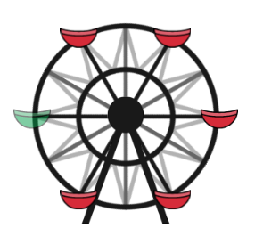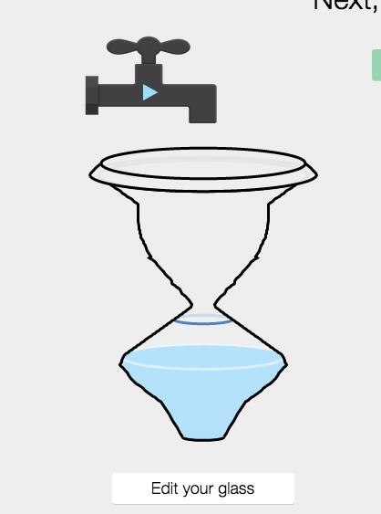
Part of the Function Carnival Part of the Water Line Activity

Who’s doing it? This program is specifically appropriate for middle and high school math teachers and their students. More specifically, Desmos is used to develop Algebra concepts.
How does it work? In Teacher Desmos, teachers chose a class activity, let’s say Water Line. Students go to the student Desmos page and type in the code provided by the teacher. They type in their name and begin the activities online. As students complete activities, their work is stored in the teacher’s dashboard. Students can go back and change or improve their work at any time. Each activity takes the concept and builds on it or approaches the concept from a different angle.
Why is it significant? The dream of Desmos is to help create “a world of universal math literacy, where no student thinks that math is too hard or too dull to pursue. When learning becomes a journey of exploration and discovery, anyone can understand – and enjoy! – math.” In the teacher desmos, which we will with play with in class, students try graphing different quantities over time such as height and distance. As students play with the activity they can correct their work and try different ways to create solutions.
What are the downsides? Unfortunately, this program does not have the space for students to comment on, improve, suggest, ask or interact with other students or the teacher. They do the activities individually and they are stored for the teacher to view. There is no interactive component where they can build on, challenge or question each other’s thinking or strategies.
What are the implications for teaching and learning? It allows students to risk, fail and try again. This is valuable because it capitalizes on the interest-driven engagement that motivates students (Parker, 2010). As a teacher, you can see the work of each student on Desmos and you can display the work of students collectively or individually to the class giving teachers a formative assessment feature. As we investigate the work of one student or look at the collective ideas of the class, students and teachers can see trends that lead to powerful classroom discussions. Maybe the best feature of this program is the fact that it helps students see the math in the world.

Technology Standards:
ISTE Teachers:
Standard 1: Facilitate and inspire student learning and creativity
Desmos promotes creative thinking on the part of the student through authentic, real world problems using digital tools and resources.
Standard 2: Design and develop digital age learning experiences and assessments
The Desmos platform for teachers allows educators to evaluate authentic learning experiences and assessments that maximize content learning in context.
Standard 4:Promote and model digital citizenship and responsibility
Desmos saves student work that can be shared with the class, which necessitates digital etiquette on the part of the teacher and students.

ISTE Students:
Standard 1: Creativity and innovation
Students can apply their existing knowledge of mathematics to generate new ideas using Desmos. Desmos allows students to use models and simulations to explore complex systems and issues.
Standard 4: Critical thinking, problem solving, and decision making
Desmos provides instantaneous feedback to students, allowing them to evaluate their precision and correctness. This motivates students to make informed decisions using appropriate digital tools and resources.
Standard 5: Digital citizenship
Because Desmos is interactive and relevant, students exhibit a positive attitude toward using technology that supports collaboration, learning, and productivity

Resources:
https://teacher.desmos.com/
https://teacher.desmos.com/activities
https://teacher.desmos.com/desman/
http://blog.desmos.com/
https://www.desmos.com/calculator

